Peter Kaufman

Java

Dr. Hezekiah

31 October 2017

Database Difference Checker (DBC)

By Peter Kaufman

Abstract

Many organizations collect data for later use. This data can be stored in many different places, one of which is a MySQL database. There is often one that is used for a development (dev) environment and one for a live environment. As time goes on, the dev environment and database change. As a result, the live database needs to be updated for the environment to run the same as the dev environment. In order to make the live database the same as the dev database, DBC was created to compare the two databases and determine the SQL statements to make them the same. The database comparison works with column, table, view, and index differences. The DBC can also work with updating a database when the dev database cannot be connected to. This is done by taking a database (DB) snapshot, which stores the structure of a database schema in a JSON file (Aaron).

Introduction

The DBC consists of twelve Java classes and JFrames and determines which columns, indices, and tables need to be added and dropped. The DBC can compare two databases using the MySQL username, password, host, port, and database name (Figure 1); take a DB snapshot (Figure 2); compare a database to a DB snapshot (Aaron)(Figure 3); catches and displays errors that occur (Figure 4); display the SQL statement(s) that was/were run last time the DBC ran (Figure 5); display the DBC run log (Figure 6); and display the DBC error log(Figure 7).

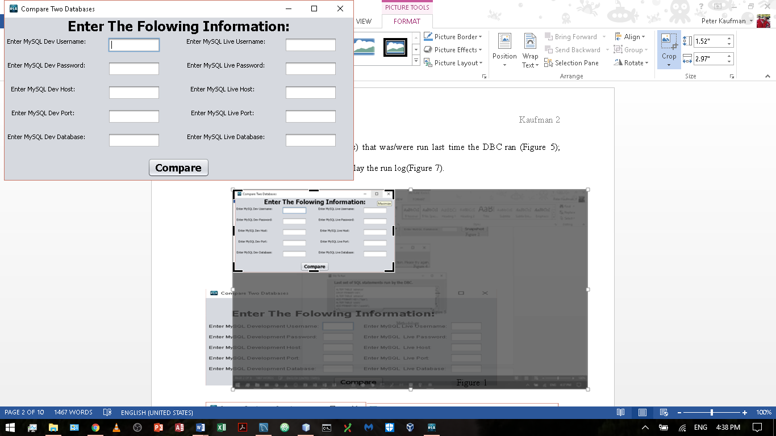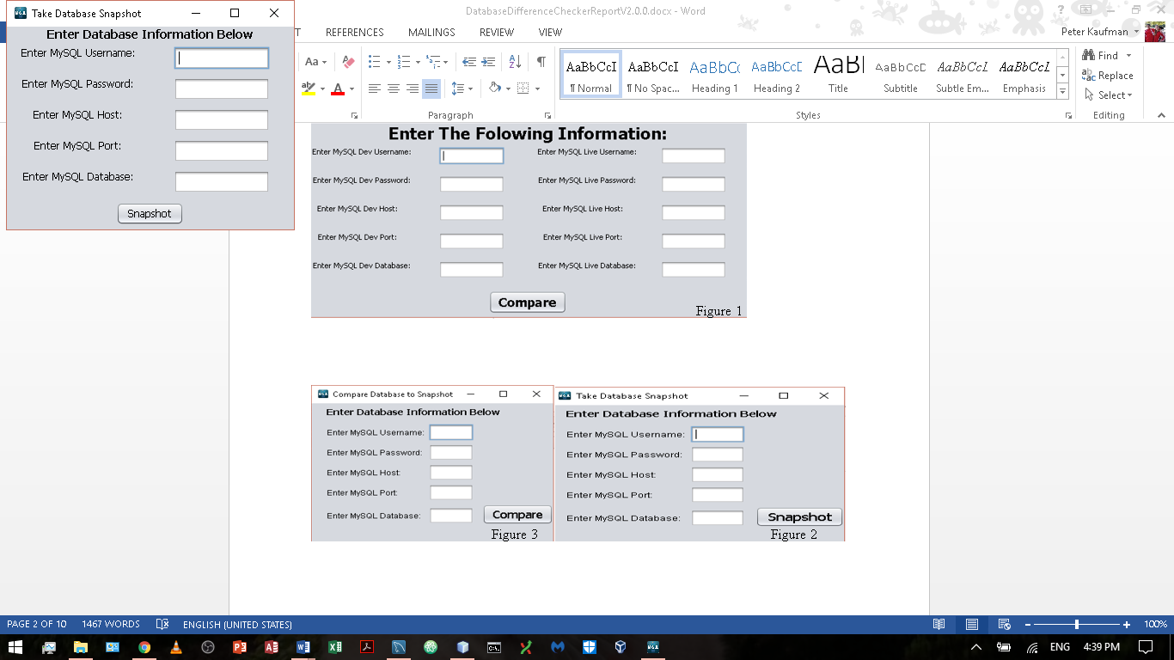 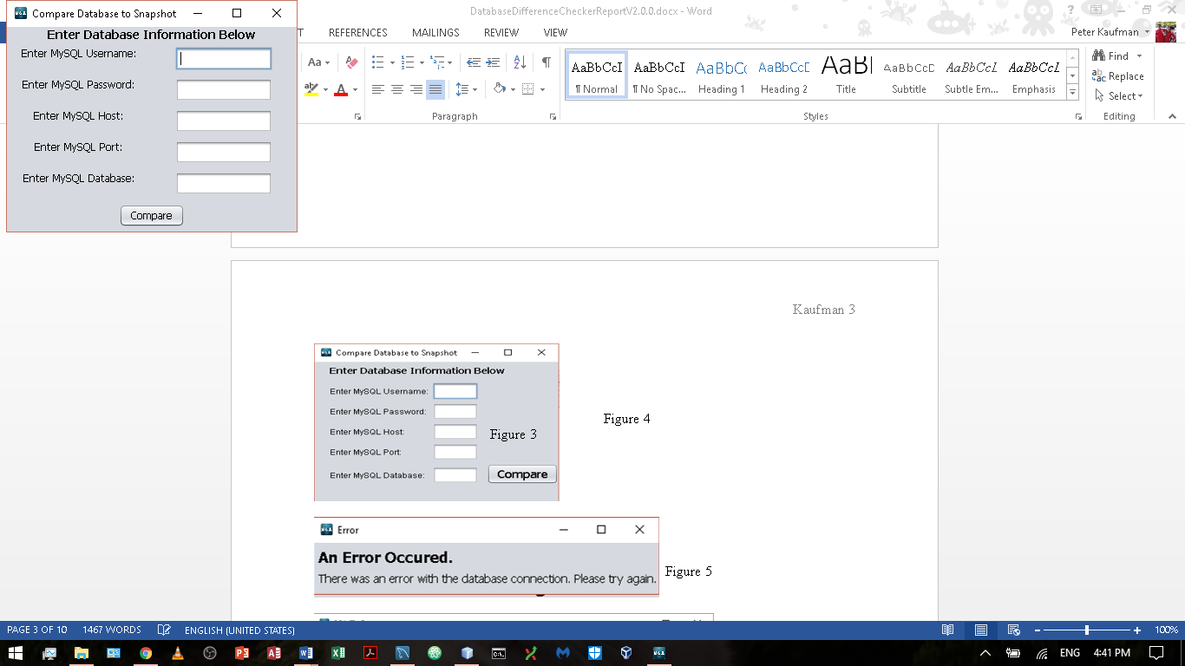 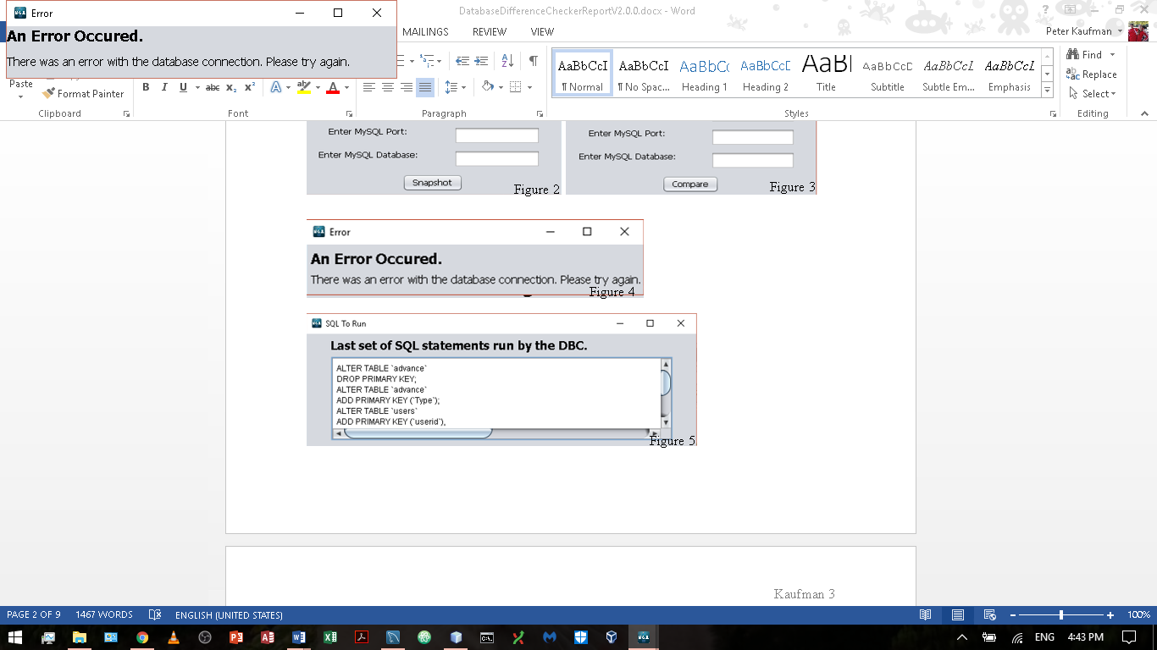

Figure 4

Figure 3

Figure 2

Figure 1

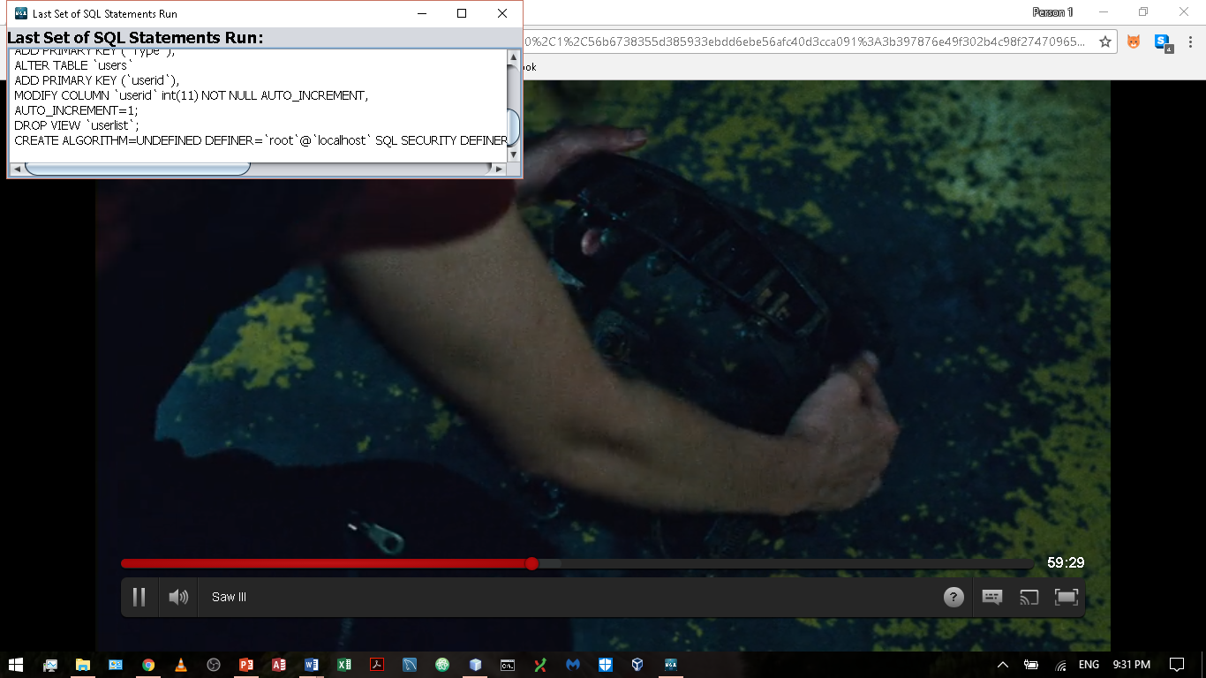 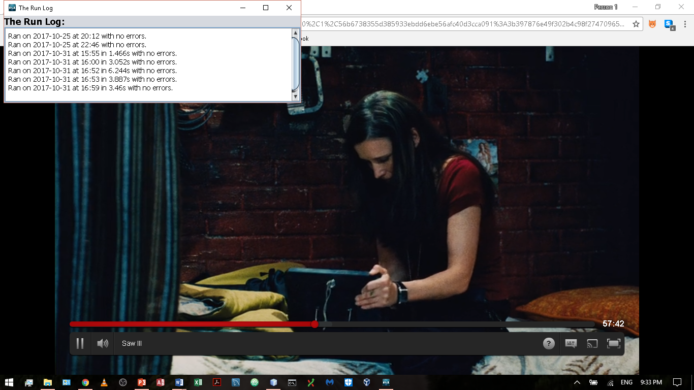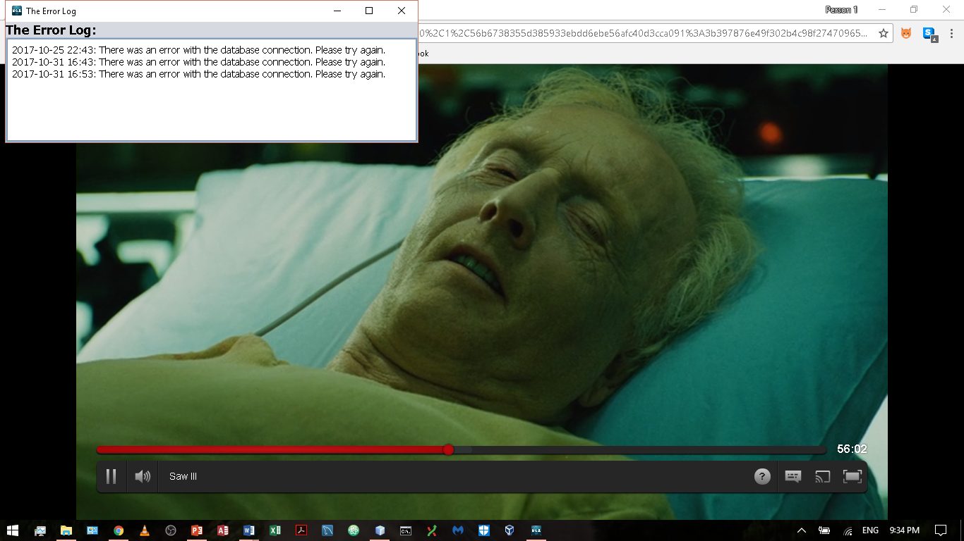

Figure 6

Figure 5

Figure 7

Methodology

The DBC consist of twelve Java classes, uses Jackson2 and MySQL connector libraries, and uses a JSON file. The DBC uses multiple JFrames to allow the JFrames to be closed and opened when needed (The Use of Multiple JFrames: Good or Bad Practice?). This allows for a more user friendly experience. When a user chooses to compare two databases using two database connections, a new window pops for the user to input information to connect to the dev and live databases (Figure 1). Once the user inputs the necessary information, a database connection is made for each of the databases. For each database, the connection is tested. If the connection is unable to be established, then an error window will pop up and inform the user (Figure 4). If the connection is established, a query is run to collect all column, table, view, and index information from the database. Collecting the index, table, view, and column information in one shot makes the program faster because there is no need to run several smaller queries to do what one larger query can do in one shot. Next, all of the live database’s primary keys are dropped and all auto increment columns are changed to remove the auto increment from the column. After that, all of dev database’s primary keys and auto increment columns are added. If these two steps are not done, the SQL statement(s) will not run without error if the dev and live have large differences in their database schemas. Once the Database objects have been initialized, the two Database objects are compared. First off, an ArrayList of Table objects from each Database object is compared to look for missing and extra tables. If any extra or missing tables are found, the appropriate SQL statement(s) is/are generated to make the table list the same. These tables are added to a list of tables to exclude from the rest of the comparisons. After the exclusion list has been made, the live database’s primary key and auto increment drop and modification statements are added to the SQL list. Third, a list of tables, which are to be updated, are compiled based on whether or not the create statements of a table with the same name in each database are the same. If any difference in the create statements is found, then the table name is added to the list. Fourth, this set of tables is then used to update these tables. The table information is compared column by column and index by index. If any are found to be extra or missing, the appropriate SQL statements are generated. For each table, all of the SQL statements needed to make the table the same in the live and dev database is put into one SQL statement to speed up the running the SQL statements. Fifth, the dev database’s primary key and auto increment add and modification statements are added to the SQL list if the table name of where the column(s) and the primary key is not found in the exclusion list. Last, all of the views in the live database have their drop statements generated, and all the views in the dev database have their create statements generated. After each of these four comparisons, the SQL statements are added to a “master list.” This list is displayed in a new JFrame where the user can copy the code in order to run it elsewhere or run it from the GUI application itself. When the user clicks the button to run the SQL statements, the “master list” is written to a file for later use. If the user chooses to do a database comparison with a DB snapshot, the process is the same except that a JSON file must be converted back into a Database object before the comparisons occur. Furthermore, if the user chooses to take a DB snapshot, a Database object is initialized, and then it is converted to a JSON file, which can be converted back to a Database object as desired later. If an error occurs at any time, a new JFrame will appear with an error message related to why the error occurred. This error is written to an external file for later use. If the user would like to see the SQL that was used to update the database last; check when a user last ran the DBC; or check to see any error that occurred, the appropriate information can be displayed by reading text from the appropriate file. Listed below are the most important methods of the DBC.

|  |  |  |
| --- | --- | --- |
| Class | Method | Description |
| DB_Diff_Checker_GUI | jContinueMouseClicked | Determines which method the user has selected and opens the appropriate JFrame |
| DB_Diff_Checker_GUI | displayResult | Opens a JFrame with the result depending on what file name is passed to it |
| DB_Diff_Checker_GUI/DBCompare1/DBCompare2/Error/Result | initComponents | Sets up the GUI Layout, sets up all action events, and initializes instance variables |
| DBCompare1 | compare2 | Compares a database to a database snapshot |
| DBCompare1 | DB1btnActionPerformed | Determines whether to take a database snapshot or compare a database to a database snapshot based on the JFrame’s title |
| DBCompare1 | takeSnapshot | Takes a snapshot of a database by converting a Database object to a JSON file |
| DBCompare2 | jButton1ActionPerformed | Determines whether the information supplied by the user is adequate. If so 2 databases are compared otherwise a message is displayed |
| DBCompare1/DBCompare2/ DB_Diff_Checker_GUI | displayResult | Opens a JFrame with the result of the comparison |
| DBCompare1/DBCompare2/Db_conn | error | Opens a new JFrame which displays the error that occurred |
| Database | tablesDiffs | Updates the list of tables which are not the same in dev |
| Table | equals | Takes in a Table and compares it to the current one, the result is the SQL statements to be run to make the two tables the same |
| FileConversion | writeTo | Turns a Database object into a JSON file |
| FileConversion | readFrom | Turns a JSON file into a Database object/Returns an ArrayList Strings which were read from a file |
| FileConversion | writeRun | Takes an ArrayList of SQL statement(s) and writes them to a file/Takes an ArrayList of Strings and writes them to a file |
| FileConversion | fileExists | Takes a file path and determines whether it exists or not |
| Db_conn | getTableList | Gets the tables, columns, and indices of the db |
| Db_conn | getViews | Gets the views of the db |
| Db_conn | runSQL | Takes a SQL statement/statement list and runs it |
| Db_conn | checkFirstSteps | Checks to see if any of the SQL statements in the fistSteps ArrayList in the exclusion list. If it is, it is removed. |

Result & Discussion

Say there are two databases one called live and one called dev as shown below (Dev, Live). If the DBC is run to make the live database the same as the dev database, the result is shown below (DBC Result). When run, these SQL statements make the live database the same as the dev database. After running the above code, the result of running the DBC again is shown below (DBC Result2). The views are the only ones that show up because any views from the live database are automatically dropped and added regardless of whether or not they are different. The primary keys and auto increment columns are drooped/added and modified regardless of whether or not they are different.

Dev:

Tables

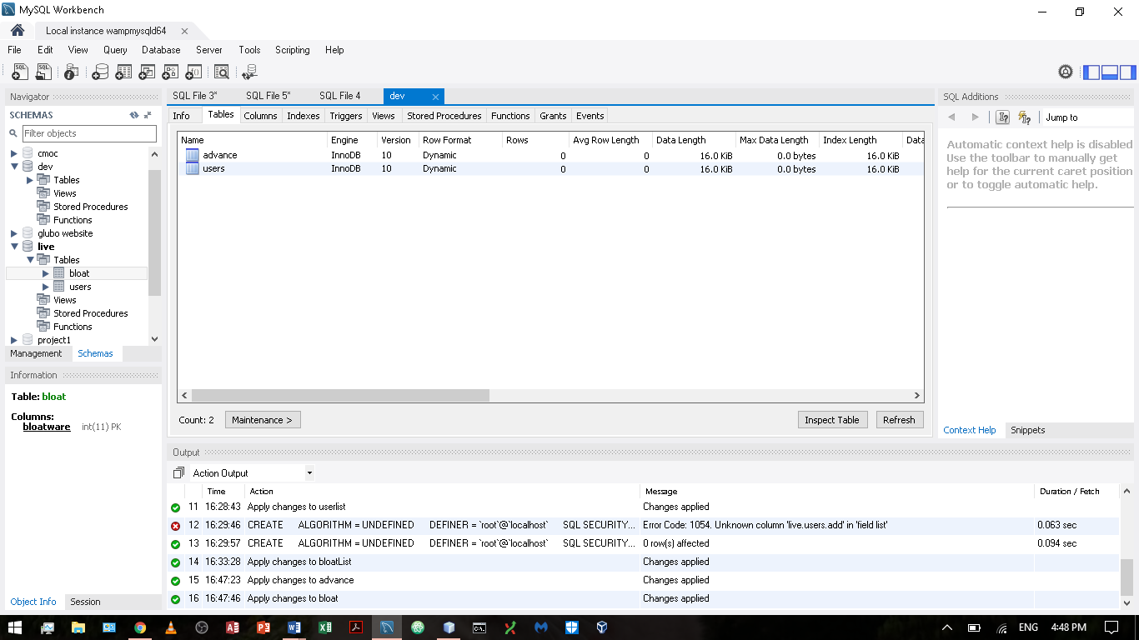

Columns

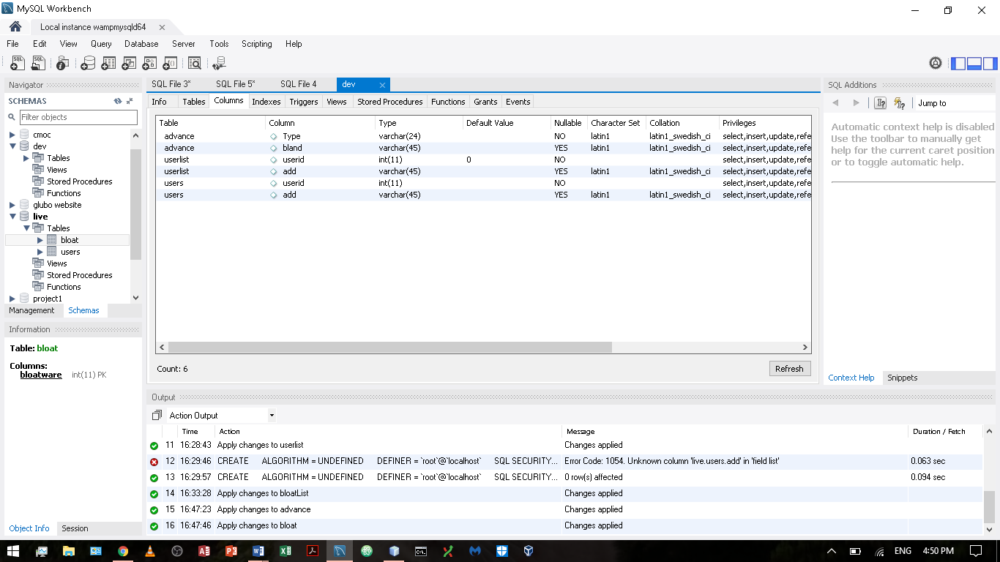

Indices

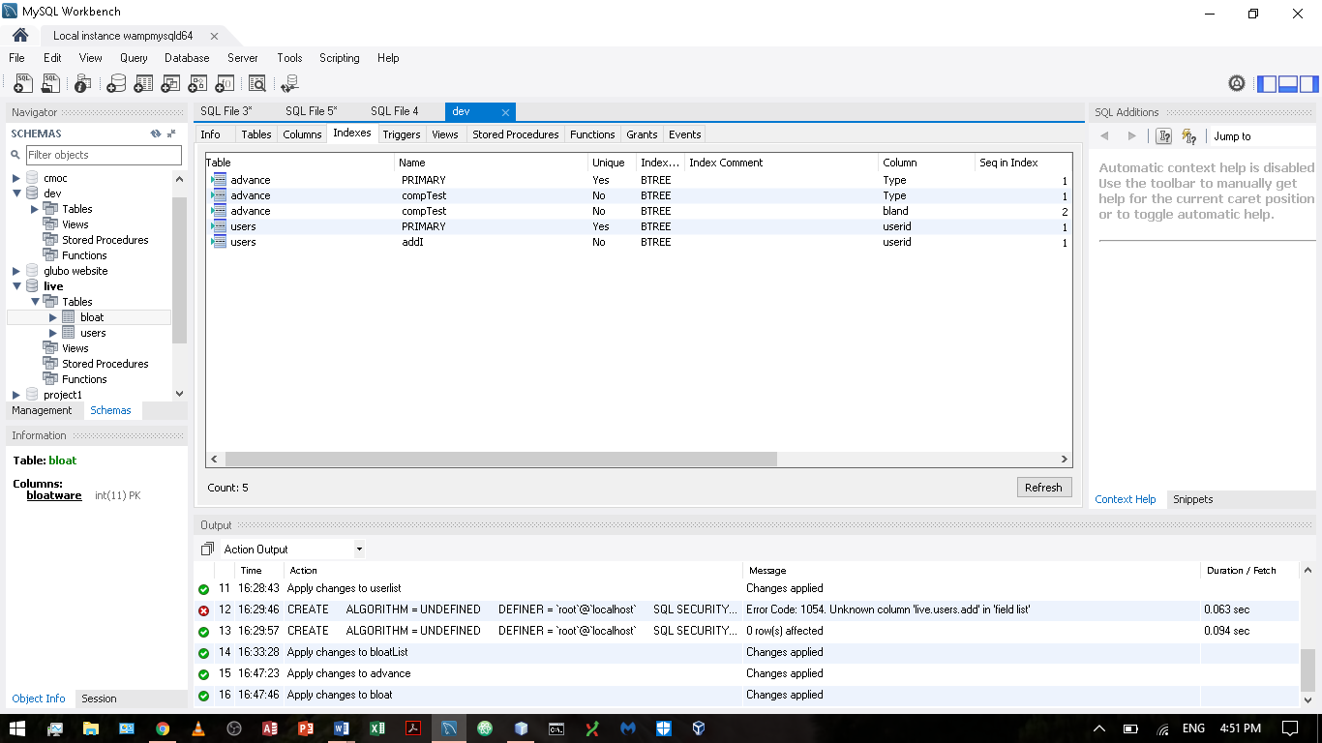

Views

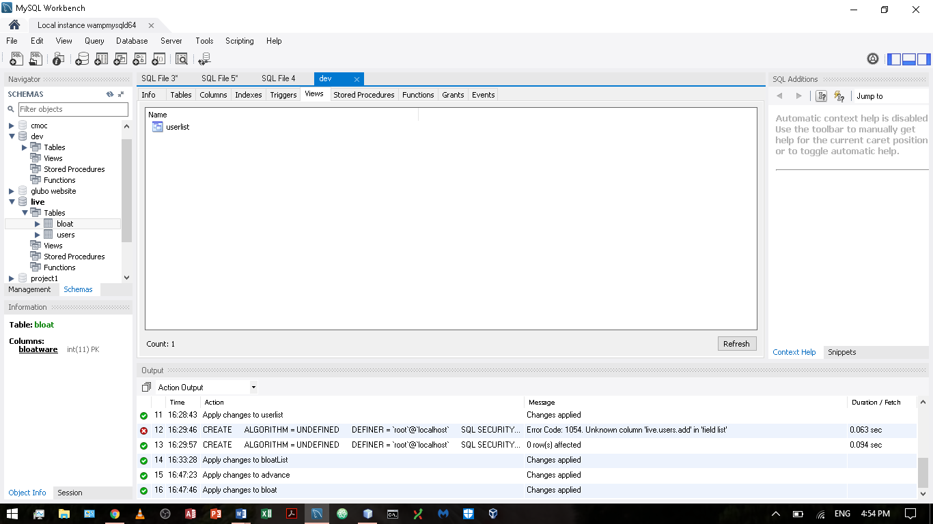

Live:

Tables

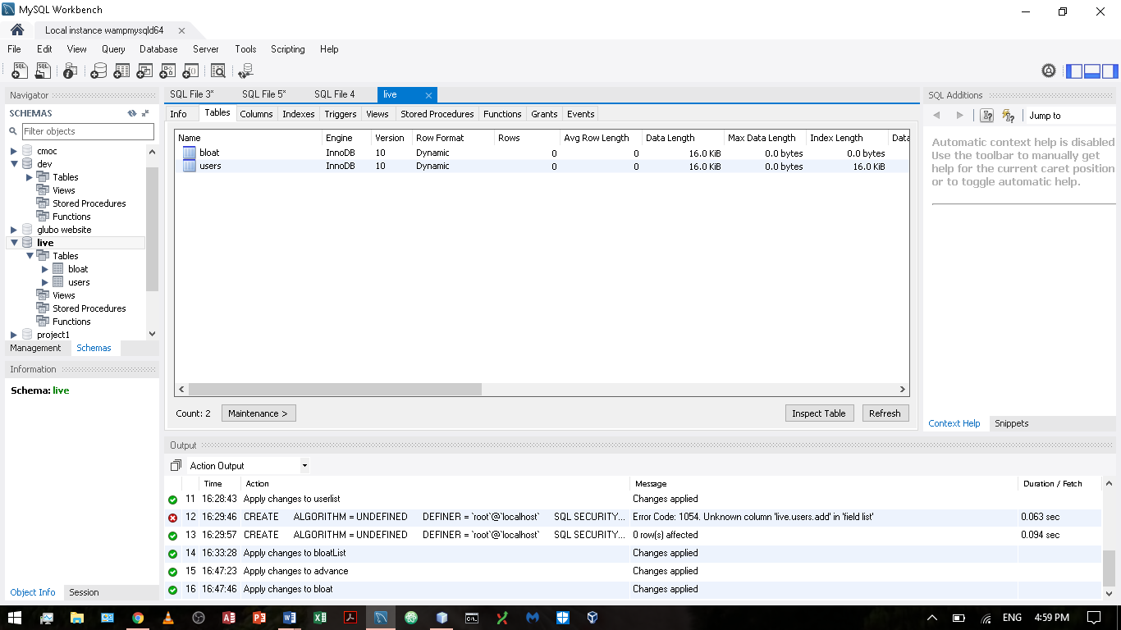

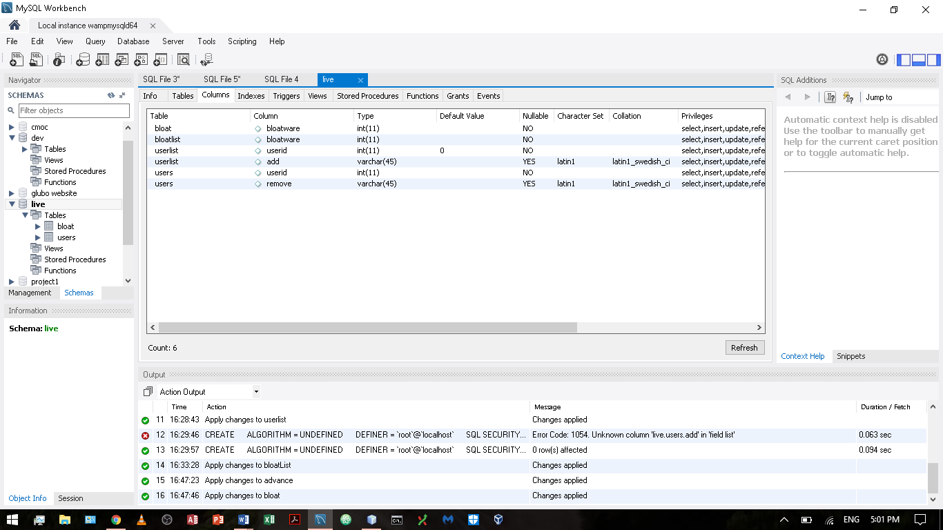

Indices

Columns

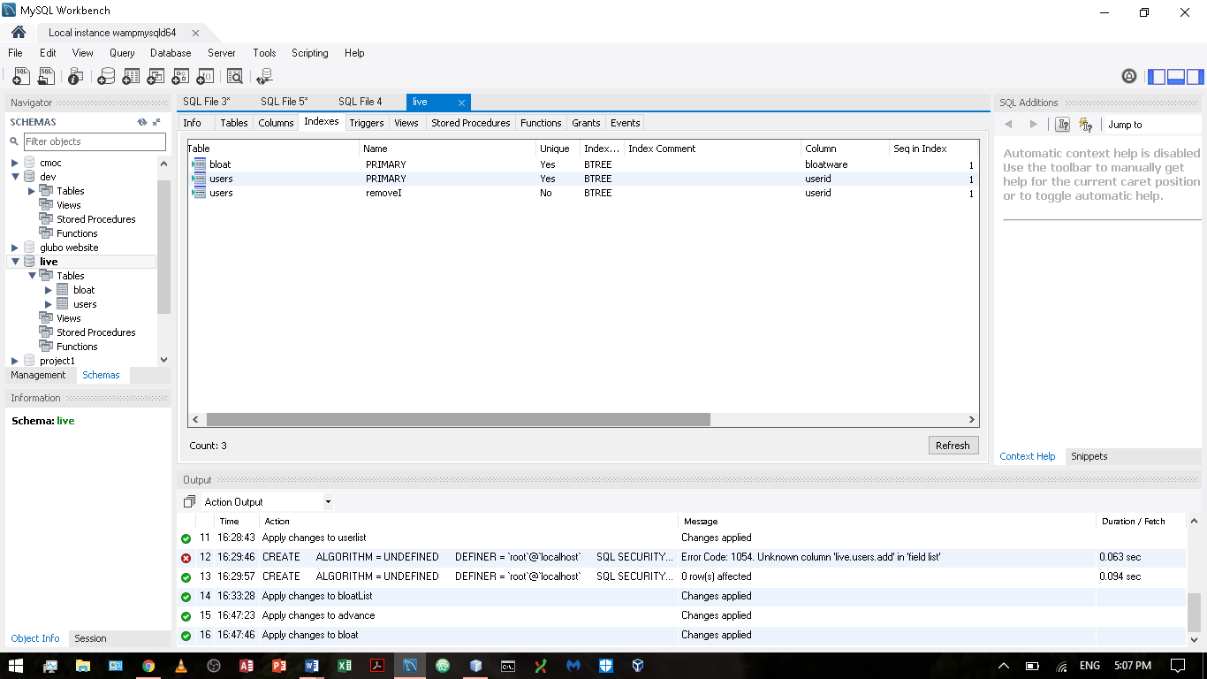

Views

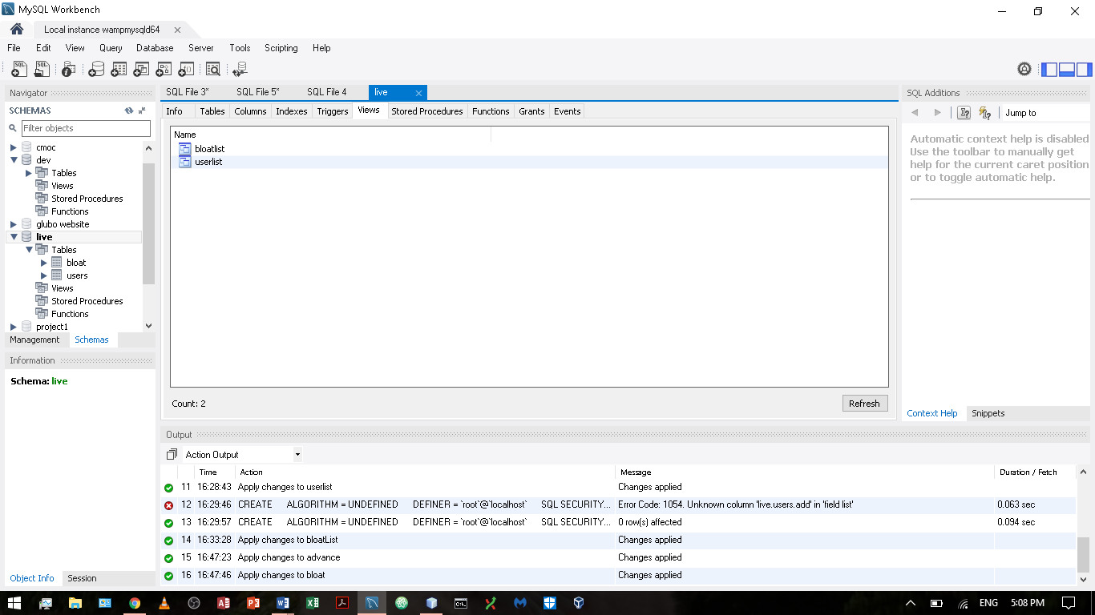

DBC Result (Default Result):

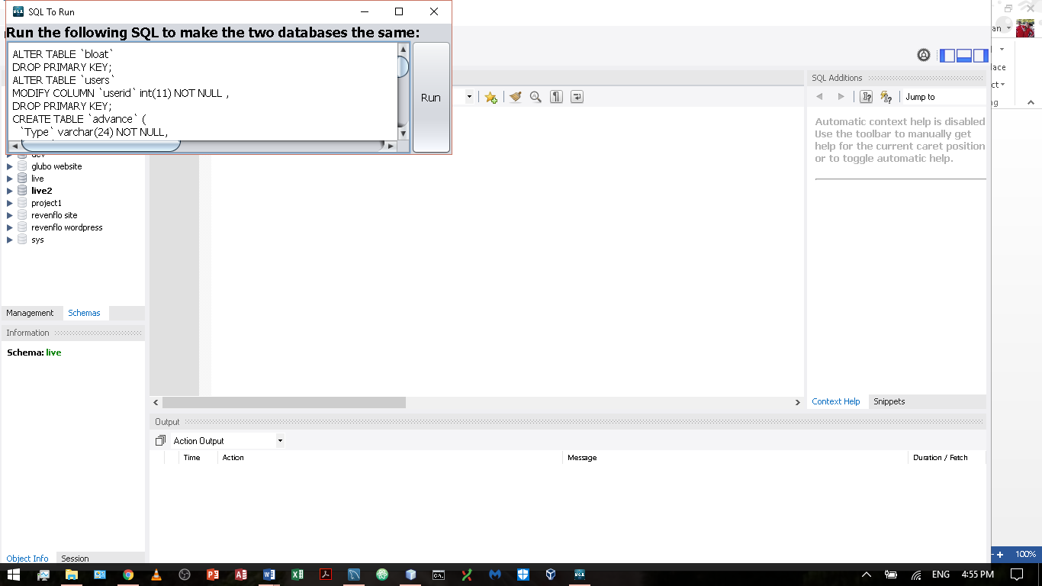

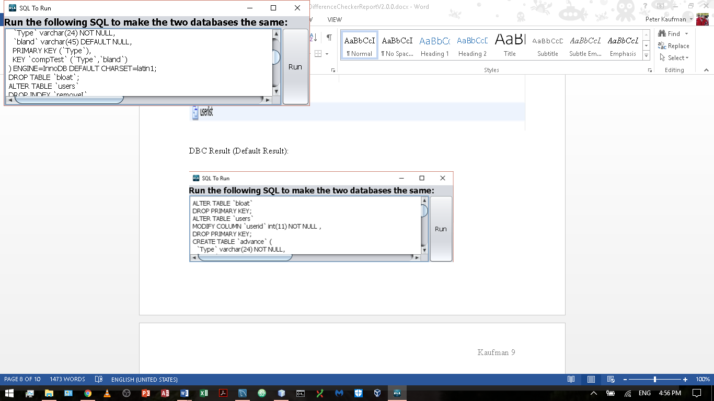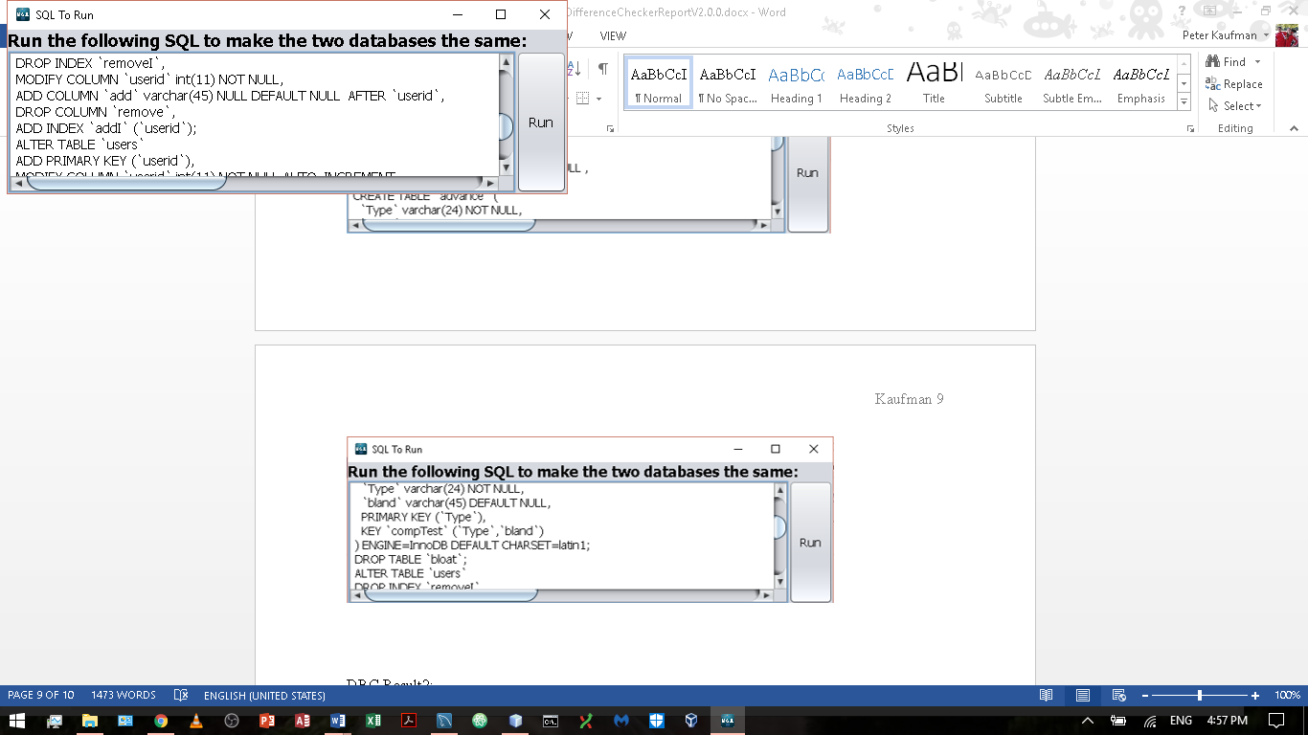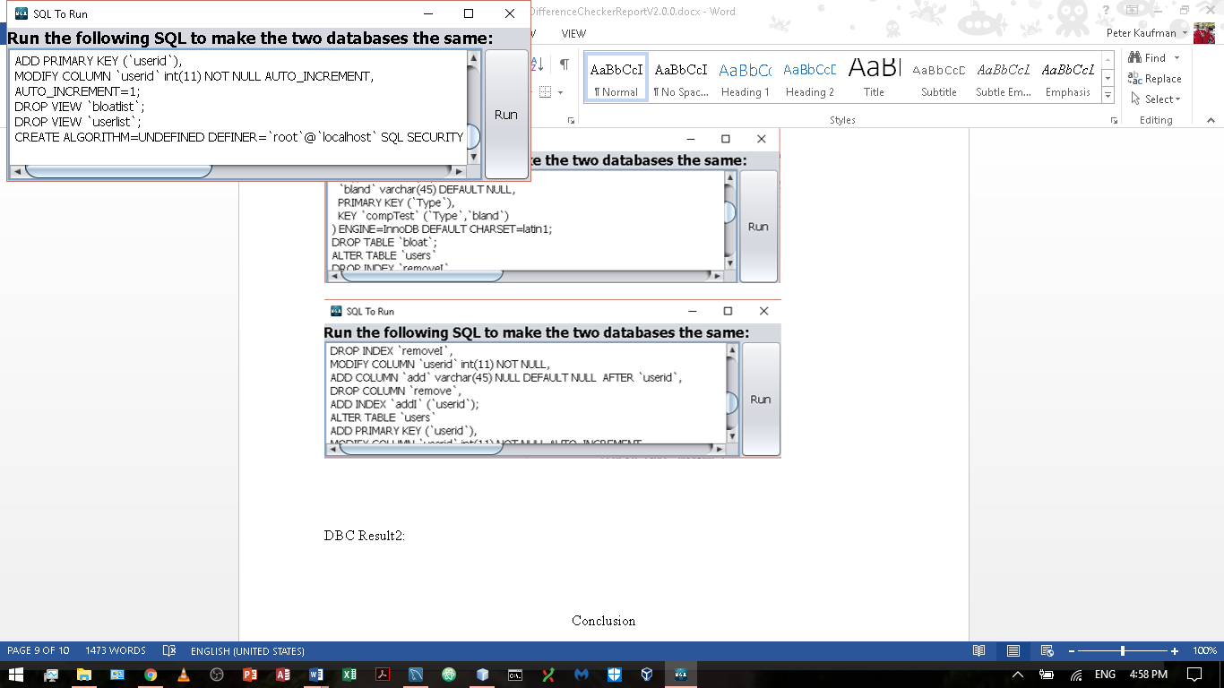

DBC Result2:

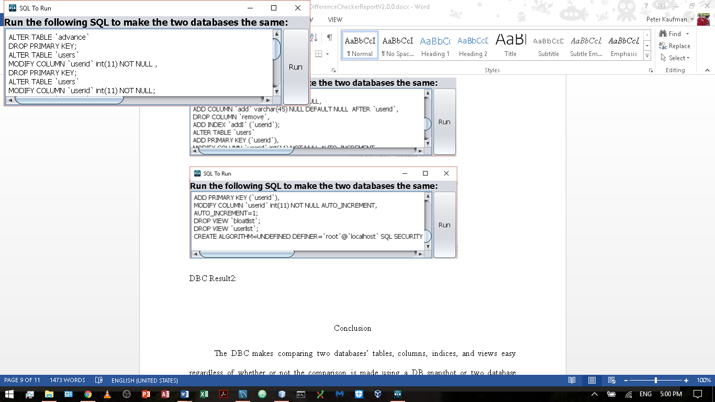

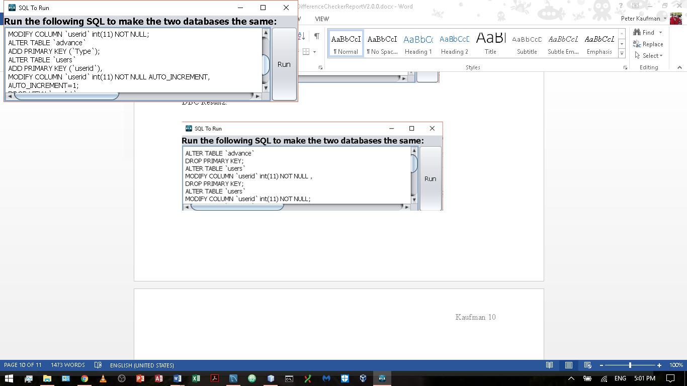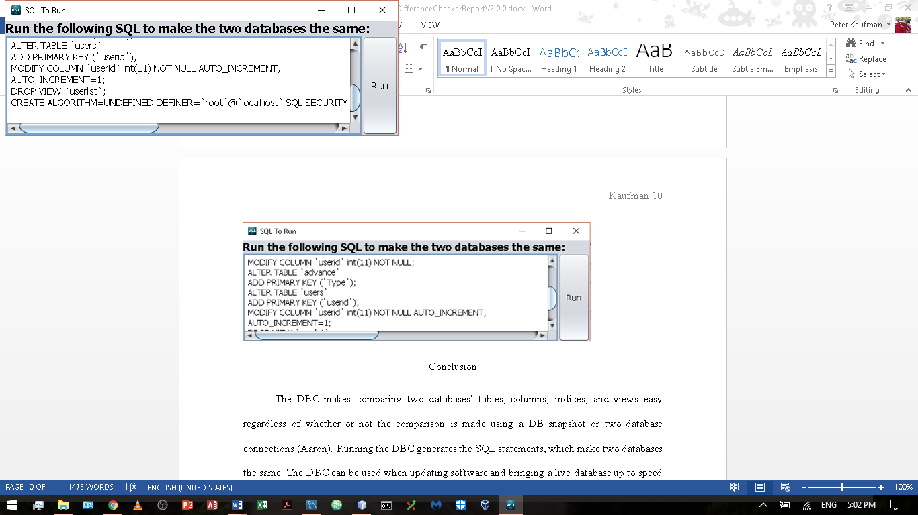

Conclusion

The DBC makes comparing two databases’ tables, columns, indices, and views easy regardless of whether or not the comparison is made using a DB snapshot or two database connections (Aaron). Running the DBC generates the SQL statements, which make two databases the same. The DBC can be used when updating software and bringing a live database up to speed with a dev database.

Works Cited:

Aaron, Rance. Personal Interview. 1 June 2017 – 11 Aug. 2017.

“The Use of Multiple JFrames: Good or Bad Practice?,” *Stack Overflow*, Stack Exchange Inc, 4 Mar. 2012, stackoverflow.com/questions/9554636/the-use-of-multiple-jframes-good-or-bad-practice.